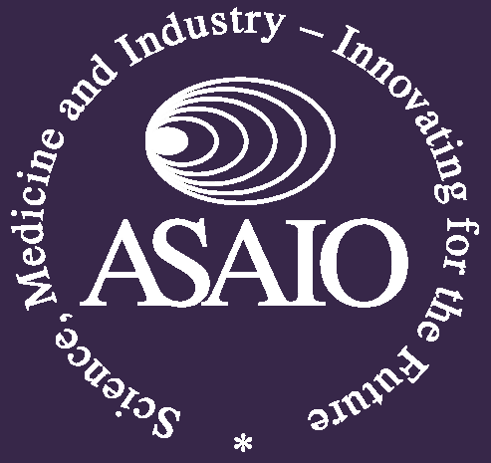
IFAO
International Federation for Artificial Organs

The ASAIO-IFAO “KIDNEW” meeting was held on June 12th as part of ASAIO 2020, covering international developments regarding Wearable & Implantable artificial kidneys (WAK & IAK).
The session was hosted by imec and chaired by Steve Ash, Murray Sheldon & Fokko Wieringa.
This was the third KIDNEW meeting in a row, and it was attended by a highly international group of Nephrologists, Technologists, Policy makers and Patient advocates, as well as by Regulatory institutions and Scientific press.
A video recording of this entire “KIDNEW” meeting can be viewed via:
https://www.youtube.com/watch?v=Rx5LOwv_qkw&feature=youtu.be.

Program:
- An International Roadmap for Innovative Renal Replacement Therapy
clock 00:01:45 Murray Sheldon, FDA, USA
- The Kidney Project
clock 00:10:29 Shuvo Roy, UCSF, USA
- Development of New Artificial Kidney Technology
clock 00:22:02 Jamie Hestekin, US Kidney Research Corp, UCLA & Univ. of Arkansas, USA
- Ambulatory Kidney to Improve Vitality (AKTIV)
clock 00:31:17 Buddy Ratner, Univ. of Washington & Center for Dialysis Innovation, USA
- The (Re)building a Kidney Consortium
clock 00:41:58 Iain Drummond, Mount Desert Island Biological Lab, USA
- Implantable Blood Purification Devices
clock 00:50:33 Morteza Ahmadi, Qidni, Canada
- Membranes for (Bio)Artificial Kidney Devices
clock 01:02:51 Dimitrios Stamatialis, University of Twente, Netherlands
- Regenerative Medicine Crossing Borders - RegMed XB: The Kidney Moonshot
clock 01:10:57 Marianne Verhaar, Utrecht University Medical Center
- Update on NeoKidney Consortium & KIDNEW
clock 01:21:26 Fokko Wieringa, IMEC & Dutch Kidney Foundation
- Experiences from Semiconductor Roadmapping &
Getting Disruptive Medical Technology Running
clock 01:33:22 Patrick de Jager, ASML
- Wrap-up Discussion & Action Points
clock 01:45:23 Steve Ash, Fokko Wieringa, Murray Sheldon, Chairing panel

In close cooperation with this KIDNEW meeting, another renal innovation meeting was held June 9th as part of ERA-EDTA 2020. This meeting was organized by the Dutch Kidney Foundation and European Kidney Health Alliance (EKHA), with a video contribution of the European Parliament.
This ERA-EDTA session can be viewed via: https://nierstichting.nl/professionals/webinar/
