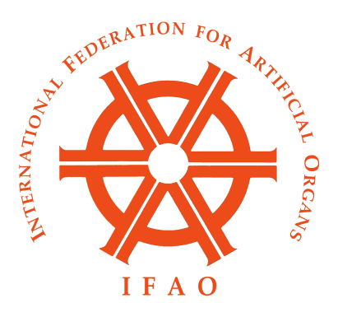

December 3, 2019

Minutes of the IFAO Formal Board Meeting
Osaka, Japan in conjunction with IFAO-JSAO
November 12, 2019

The IFAO Board met in the Umeda Sky building in Osaka at 1 PM on November 12. Attending were Profs: Masuzawa (Chairman), Ash (Secretary Treasurer), Nishimura, Schima (by Skype), Groth (by Skype), Legallais. Sawa (IFAO 2019 Congress Chair), Toda (JSAO 2019 Congress Chair), Malchesky (Editor), Stegmayr (Ex Chairman). A box lunch was served.

The meeting was called to order by Chairman Masuzawa. The first order of business was the recognition of new Board Members as nominated by the continental societies. Prof Cecile Legallais from Compiegne was nominated as representative from ESAO and Prof Takashi Nishimura from Ehime was nominated as representative from JSAO. Both were approved and enthusiastically accepted by the Board. Next, the minutes of the June 2019 informal Board meeting of IFAO in San Francisco were read and approved. Next was election of new officers of the IFAO Board. Prof Peter Wearden of Orlando was nominated by ASAIO as Chairman from 2020-2021. The Board unanimously elected him Chairman. Prof. Heinrich Schima was nominated by ESAO as Vice-Chairman for 2020-2021. The Board unanimously elected him Vice-Chairman. Prof. Thomas Groth was nominated by ESAO as Secretary-Treasurer for 2020-2023. The Board unanimously elected him Secretary-Treasurer. A list of the IFAO Board and members is attached to these minutes.

Next the Secretary-Treasurer gave a report on the finances of IFAO. The endowment and investment portfolio of IFAO has remained approximately stable over the last several years. The annual income of dues from member societies accounts for $7,500 income every year. Every two years payment is made to sponsor the Federation Congress, and that is $25,000 (as specified in the society written Policies). A few other payments are made during the year, such as costs for Board meeting meals and refreshments. The interest and dividends from investments, plus the dues from members roughly equal the yearly expenses of IFAO.

The next order of business was a discussion of how IFAO may help the Kidney Health Initiative (KHI) initiative in the U.S., and similar programs in Japan and Europe. As stated in the minutes from the June Board meeting, KHI is a cooperative effort between ASN and FDA, to promote innovation in the therapy of CKD and ESRD. KHI has launched the Kidney-X program to fund innovations in dialysis therapy, and also the Renal Replacement Roadmap to define the technologic challenges to developing the next generation of renal replacement therapy. KHI also launched an effort to define optimal fluid management on dialysis. Dr. Murray Sheldon of FDA approached the IFAO Board to see if we could help to internationalize this effort. Many of the new innovations in dialysis therapy have been made by ESAO and JSAO members, and there are on-going projects to develop highly portable or wearable renal support devices. In June, the Board heartily endorsed the KHI initiatives and offered to help their publication in any way possible.

The Board discussed possible ways that IFAO could assist in giving international exposure and interest to the KHI initiative. Currently, the Board of IFAO creates a scientific session at the Federation Congress held every two years with one of the member societies. The focus is usually on application of artificial organs around the world, or new fields of research of general interest. We also offer to create similar scientific sessions for each meeting of the member societies every year, if possible. In order to promote the interests of KHI and IFAO, we could plan to create sessions at three member society meetings in 2020 which focus on new approaches to treatment of uremia and potential improvements in dialysis therapy. The idea is that these sessions could be organized by IFAO and KHI together. Our member societies include many of those with a history of efforts to improve dialysis therapy. If some monetary support is available from KHI to offset some travel expenses, the sessions could include outside speakers with particular interest in ESRD therapy improvement, without requiring extra monetary input from IFAO. I have conveyed this idea to Dr. Sheldon, but have not received a reply as yet.

If this program is successful, then IFAO might plan to create similar programs in the future which focus on improving artificial organ therapies. This could be done in conjunction with other societies or governmental agencies with programs designed to improve other artificial organ devices and their implementation (heart, lung, neurological, etc).

The next informal Board meeting of IFAO will be during the IFAO-ASAIO Congress in Chicago, June 10-13, 2020.

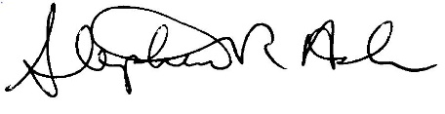
Stephen R. Ash, MD, FACP
Secretary-Treasurer
IFAO

https://www.kidneyx.org/PrizeCompetitions/PastCompetitions/redesigndialysisphasei
https://cjasn.asnjournals.org/content/clinjasn/14/10/1539.full.pdf
https://khi.asn-online.org/uploads/KHI_InnovationsInFluidManagement.pdf

