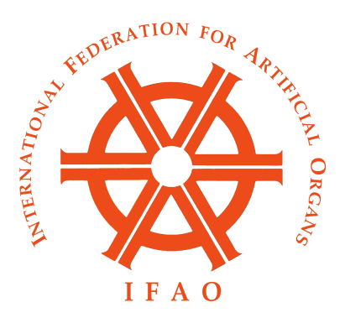

IFAO BOARD MEETING MINUTES
WASHINGTON HILTON
June 14, 2018 (During the ASAIO Meeting)
7:30 PM

- Attendance:
Board Members in Attendance were: Professors Masuzawa (Chairman), Groth, Schima, Matsuda, Toda, Slaughter, Invited guests included: Prof. Taenaka, Angela Hadsell (Managing Editor of Artificial Organs), Prof. Murray Sheldon (from FDA, on behalf of KHI and KidneyX), Prof. Fokko Wieringa (from TNO, representing the Dutch Kidney Foundation and NeoKidney). Dr. Ash (secretary) organized the agenda with Prof. Masuzawa and attended the meeting.
- Dinner was served,, and the business session followed.
- IFAO Sessions for continental annual meetings:
Discussion was held regarding the IFAO sessions-held during annual continental society meetings. It was agreed that these sessions, which usually contain three scientific presentations, are a valuable part of these annual meetings. The sessions emphasize the important role of IFAO, and also add unique topics and perspectives to the agenda of the meetings. For speakers who come to these meetings at the request of IFAO, the IFAO session organizers should ask the host society to cover at least some of the expenses of the speakers. Speakers are needed for the following IFAO sessions:
- ESAO Madrid Sep 12-15 2018 needs an ASAIO speaker; Prof. Slaughter agreed to find a speaker for this session. .
- JSAO Tokyo Nov 1- 3 2018 needs an ASAIO speaker, Prof. Slaughter will also find a speaker for this session.
- ASAIO June 2019; IFAO session is in planning.
- JSAO-IFAO Congress in 2019 (Osaka, November 12-15, 2019)
Prof. Toda gave a report on the preparations for the joint JSAO-IFAO congress in Osaka in 2019. The program has been planned, colorful advertisements published, and invitations will soon be made for all speakers. There will be grants for young investigators to attend the meeting, and a focus on overseas attendees.

5. Various society initiatives to spur innovations in dialysis therapy
There have been a number of initiatives by professional societies and government agencies to increase innovation in dialysis therapy and develop new technology to support patients with ESRD. Prof. Wieringa discussed the KIDNEW program by ESAO. He also described the NeoKidney program initiated by DKF. Prof. Sheldon discussed the Kidney Health Initiative sponsored by ASN and FDA, which now includes over 90 agencies and other stakeholder in renal therapy. One committee of KHI is the Renal Replacement Therapy “Roadmap” committee. They are outlining new technologies needed for highly improved renal replacement therapies. Prof. Sheldon also discussed the KidneyX project by HHS and ASN. With the possible support from CMS and NIH, this program may fund projects leading to next generation dialysis and alternatives to dialysis.

6. Financial report of IFAO
The finances of IFAO are stable, with expenses equaling income from the member society dues and investment income. Some older investments with relatively low gains have now matured, and higher yields are expected from planned reinvestments. As in the past, Mr. Pat Walsh of remain our advisor at Merrill Lynch to advise us on how to direct these investments. His summary of our investment status was distributed to members before this meeting.

- Artificial Organs journal report
The Artificial Organs journal continues to be successful, with subscriptions increasing and article readership increasing. Over 150,000 article downloads are made yearly. Impact factor is stable at 2.4, at or above the rating for each of the other artificial organ journals.
- Report on Asia Pacific Society for Artificial Organs meeting

The APSAO 2017 meeting was held in Thiruvananthapuram, Kerala India October 25-27, 2017. The meeting was planned with the assistance of JSAO, and jointly hosted with the 6th Asian Biomaterials Congress (ABMC6). It was well attended and successful.
The upcoming APSAO 2018 conference will be held in Taipei, R.O.C., Taiwan, on October 25th-26th 2018. The Conference Chairman is Dr. Jeng Wei. Information on the program is found at http://www.heart-forum.org/index.php

- Next IFAO Board meeting
The next IFAO Board meeting will be in Osaka at the IFAO-JSAO meeting described above.

Stephen R. Ash, MD, FACP
Secretary of IFAO

